**Reusable Component: Bulk Data Export to Excel**

**Problem Statement:** While exporting the data through Excel it can handle only 65535 (approx.) records at one time and the functionality breaks if there are a greater number of records. Because the **Java Action range is from (0 to 65535) we can't export beyond this range.**

**Solution:** Our approach is to break the data and into n parts and then export them to different excels

**Implementation –**

* Retrieve from Data base – All: the list of original bulk data that you want to Export in Individual Excel and find the number of total records in the list.  
  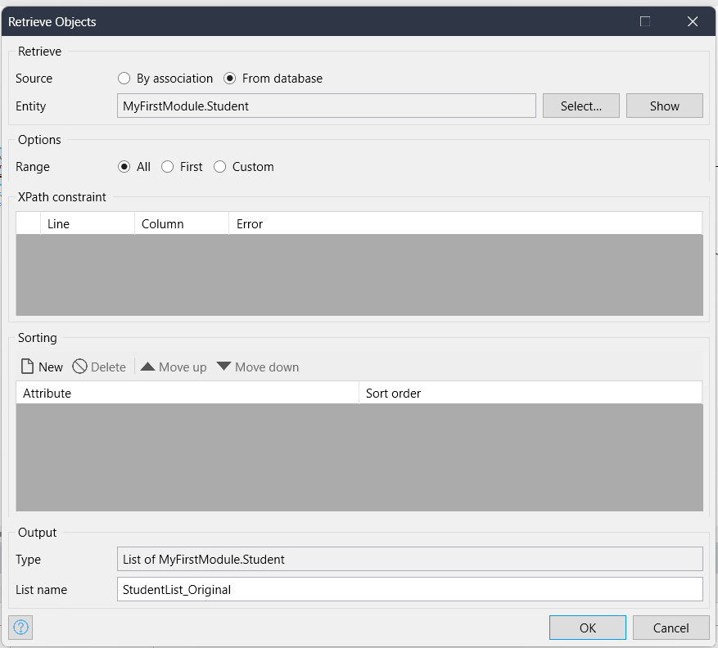
* Retrieve from Data base – Custom: Create variable to set default value for Offset, Amount, VariableN and LoopCounter.
  + **Offset** - a value that indicates from where you want to Retrieve the data (starting at a given index).
  + **Amount** - Retrieve a given number of objects that you want.

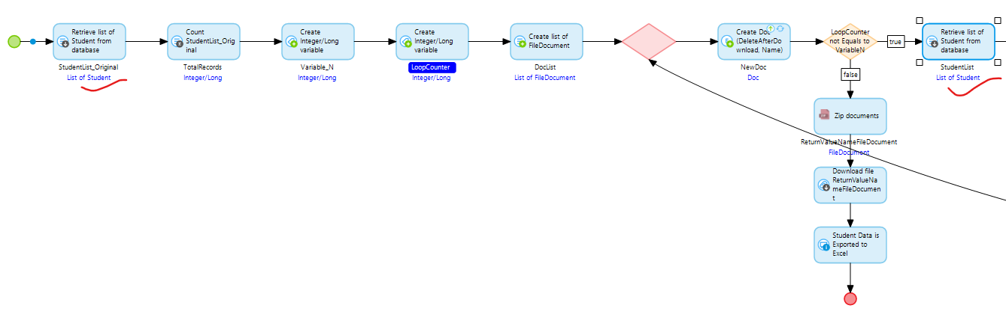

* To get the Zip file for the list of documents that we have to pass the list to Java action ‘Zip Document’ activity and a object of System.FileDocument where we can define the name of the downloaded Zip file.   
  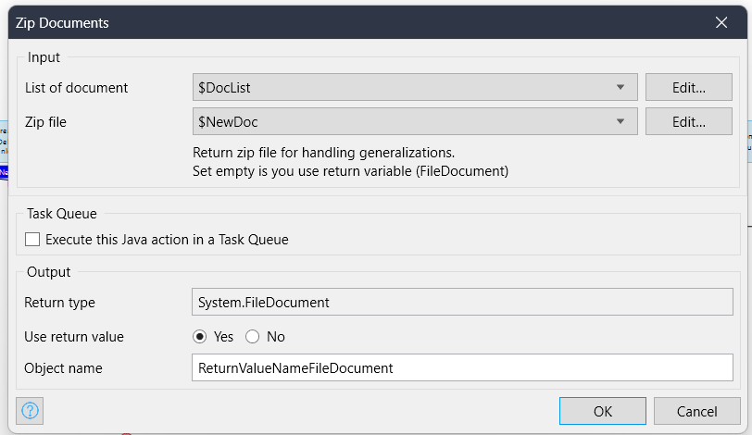
* Passing ReturnValueNameFileDocument to the Download File activity, and you will be able to Download Zip file of exported Excel files.